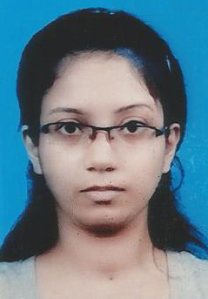

SRIJITA CHAKRABORTY

A happy-go-lucky Gemini who loves to paint

Permanent Address- Belghoria, Kolkata-700056
Contact – 8697565612/7278868624
Email.id – srichakraborty24592@gmail.com

Father’s name: Mrinal Chakraborty
Nationality: Indian
Date of Birth: 24-05-1992

EDUCATIONAL QUALIFICATION
- Passed ICSE in the year 2008 from Central Modern School.
Subjects: English, Bengali, Science, History, Geography, Environment Education.
Marks: 75%
- Passed ISC in the year 2010 from Central Modern School.
Subjects: English, Bengali, Political Science, Economics, Geography, Math & Environment Education.
Marks: 81.75%

- Passed B.A (H) from Maharaj Manindra Chandra College in the year 2014.
Subjects: Journalism and Mass Communication (h), Political Science (pass), Elective English (pass).
Marks: 58.25%

- Pursuing MBA from ISBM (Indian School of Business Management)
Specialization: Media management & Advertising Management.
WORKING EXPERIENCE


- Organization: Inforain Web Solutions
Tenure: 27th April 2015 - 22nd January 2016
Position: Content Writer

My role/responsibilities- My job role was to write articles, blogs, reviews and press release over various topics. I know to write the Home page and About us section and have well knowledge on e-commerce product description. During my 9 months of tenure I wrote all sorts of articles and blogs covering various topics like management, broker & finance, technical, educational, tourism, casino, fashion, architects, security, aquariums, cars, Sardinian food blog, maid, Muslimah dresses, hair products, yoga & spa, salon & camping products and many more.
The projects I have worked on are- Calcamp, Tuscanypro, Shuzee, VolumeProducts and Lavaannya.


- Organization: Royal Research Pvt Ltd.
Tenure: 21st March 2016- 11th June 2016
Position- Academic content writer

My role/responsibilities- As an academic researcher, my rob role was to write dissertation, report, essay, proposal, blog and assignment.

Declaration: I do hereby declare that the above information is true to the best of my knowledge and belief.

Srijita Chakraborty

